Ermac Voxel Game
“NEWGEN”
Game name: “Demolition Synergy”
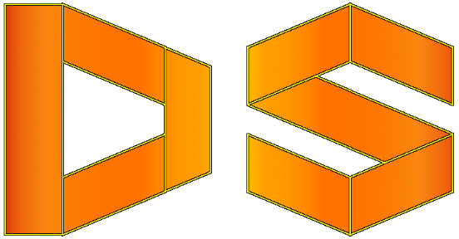

Game Description:
Game combines first person shooter, sandbox and voxel properties. It is uncomplete and in continuous development process.

Source Repository:
https://github.com/ErmacMKIII/DemolitionSynergy

License:
GNU General Public License v3.0

Game assets structure (by entries):
- effects – contains shaders (according to the OpenGL 3.3 and GLSL 3.3);
- intrface – loading images for interface such as crosshairs, fonts (F2IBuilder) and stuff for menus;
- player – models (.obj format) and textures (.png format) for the player assets;
- sound – contains music and sound fx audio files (.ogg format);
- world – contains models (.obj format) and textures (.png format) for blocks which make environment as it is.
All five entries constitute together one archive which is dsynergy.zip.

Available commands:
In order to type command which is equivalent to options setup press key “~”.
- fps_max<num>, fpsMax<num>: allowing to change max fps (it must be positive number).
- resolution<width><height>, res<width><height>: allowing to change resolution (min resolution is 640x480 whilst max is your native resolution).
- fullscreen: makes your game run fullscreen.
- windowed: makes your game run windowed mode.
- v_sync <bool>, vsync<bool>: whether or not you wanna vsync on or off. If it’s on (you’ve set it to true) your fps is capped to your monitor refresh rate.
- water_efects <bool>: enables (true) or disables (false) water effects (such as reflection).
- mouse_sensitivity<num>, msens <num>: sets mouse sensitivity to this value.
- music <num>, sound <num> : sets respectively music and sound volume to this value.
- screenshot: take a screenshot (uses folder screenshots).
- position: get/set position and (or) chunk.
- sizeof[<chunkId>]: get total size without args, if args provided size of blocks of that chunk.
- quit, exit : leaves the game.

HELP

Camera movements:
W, UpArrow = Forward
A, DownArrow = Backward
S = Strafe Left
D = Strafe Right
LeftArrow = Turn Left
RightArrow = Turn Right

Player functions:
1 = Pistol
2 = Sub Machine Gun
3 = Shotgun
4 = Assault Rifle
5 = Machine Gun
6 = Sniper Rifle
Mouse1 = Fire [Not implemented]
Mouse2 = Alt-Fire [Not implemented]

Editor functions:
N = Create New Block
M = Change Block Color
Mouse1 = Select Solid Block
Mouse1 + SHIFT = Select Fluid Block
Mouse2 = Place New Block
1-6 = Select Adjacent Solid Block
1-6 + SHIFT = Select Adjacent Fluid Block
F, 0 = Deselect
R = Remove Selected Block
[, ] = Change Texture For New Block

Other functions:
` = Enter Command
ESC = Main Menu
F1 = Help
F2 = Save Level
F3 = Load Level
F12 = Take Screenshot
P = Change Crosshair Color

Notes:
- Game uses LWJGL 3.2.3 since v 02 (BELARUS).
- Game requires Quad Core processor with support for at least 4 threads. Game implementation is multithreaded (at most time 3 threads will be active + 1 additional thread if random level generator is being used or when loading or saving level is in progress).
- Running the game requires OpenGL 3.3 (on graphic cards since March 2010) or later.
- Game is implemented using Java version 1.8. (requires 1.8 or higher).
Author: Alexander “Ermac” Stojanovich (email: coas91@rocketmail.com; Discord: ermac #1844)
Testers: JSomnia, Hellblade64
Audio material was provided from freesound.org by Erokia.

